CDOT Records
Items: 8 Zoom Regions (Including Introduction)
Duration: 40 seconds

The CDOT Records Destruction Inventory Form
5 seconds
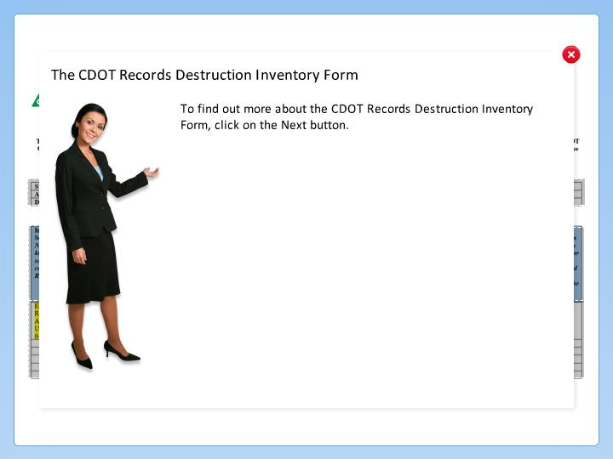

Step Text
To find out more about the CDOT Records Destruction Inventory Form, click on the Next button.

Narration Script
The CDOT Records Destruction Inventory form must be completed and approved before any record is destroyed. Click on any of the areas shaded in gray to learn more about the field.

Submission and Approval
5 seconds
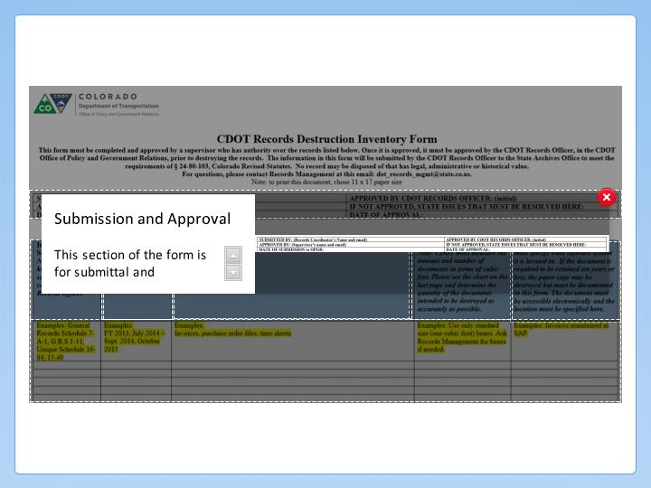

Step Text
This section of the form is for submittal and approvals of the form.

Narration Script
This section of the form is primarily for the submitting and approval form with one notable exception, if the form is rejected CDOT's Record officer then an explanation about what you need to do would be entered and sent back to you. Some of the most common reasons are that the records still need to be retained or that the years of the records were not clear or included.

Item Number
5 seconds
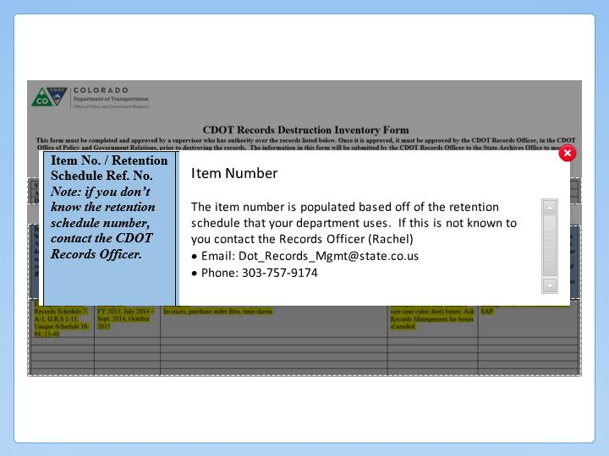

Step Text
The item number is populated based off of the retention schedule that your department uses. If this is not known to you contact the Records Officer (Rachel)
- Email: Dot_Records_Mgmt@state.co.us
- Phone: 303-757-9174

Narration Script
The item number is populated based on the retention schedule your department uses. If you are uncertain about what the retention schedule your department uses or you are not certain, contact the Records Officer using the contact information on this slide.

Date Range of Record
5 seconds
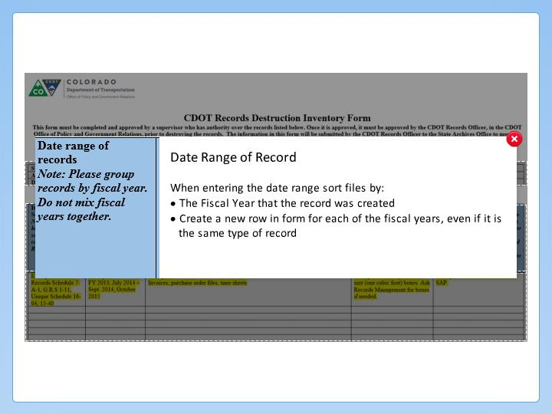

Step Text
When entering the date range sort files by:
- The Fiscal Year that the record was created
- Create a new row in form for each of the fiscal years, even if it is the same type of record

Narration Script
In this field enter the Fiscal Year, of the record and the month it was created. When you sort the files keep like fiscal years together and then sort by the type of file. For example, timesheets, purchase order and the like. When storing the records you should also store them in a separate box and folders.

Description of Record
5 seconds
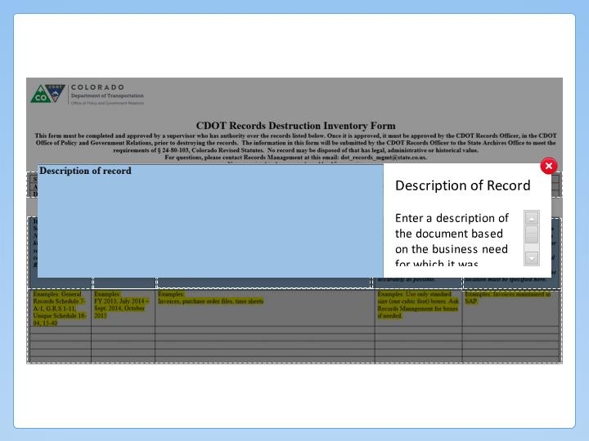

Step Text
Enter a description of the document based on the business need for which it was created.

Narration Script
The description is just that, a brief description of what type of record. This is based off of the business need for which the record was created, for example, timesheets for the XYZ Project.

Quantity
5 seconds
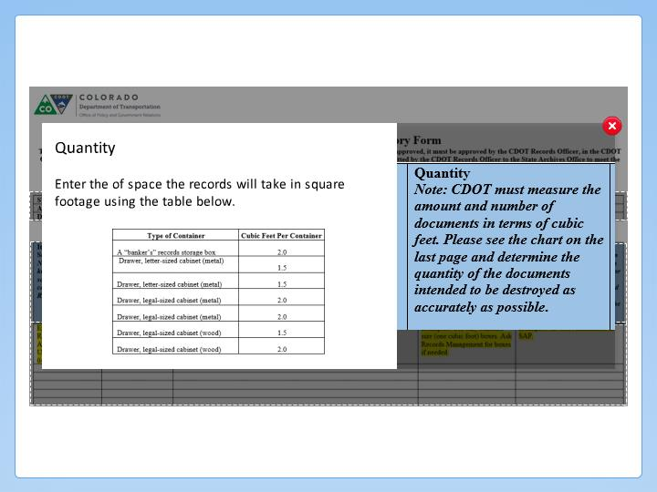

Step Text
Enter the of space the records will take in square footage using the table below.

Narration Script
Enter information in this field of the form only if you are working with physical records. If the record is electronic, use the field to the right of this one. This field helps us determine the storage needs and the pricing when the records need to be destroyed. To assist you there is a table at the end of the form. Click on the image to display the cubic feet per container table provided on the form.

Electronically Retained
5 seconds
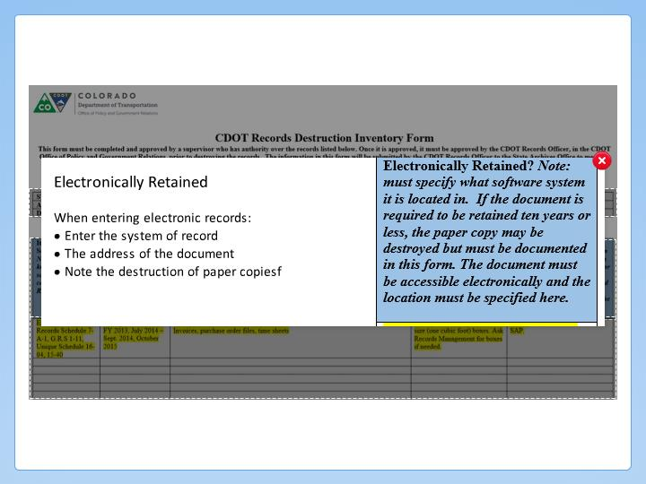

Step Text
When entering electronic records:
- Enter the system of record
- The address of the document
- Note the destruction of paper copiesf

Narration Script
Enter information in this section of the form only if you are working with electronic records. You should enter the system where the file is being saved and the address of the document so it can be retrieved. If the record was printed out and you are only retaining the electronic record you should note you are doing so.

Sample Information
5 seconds
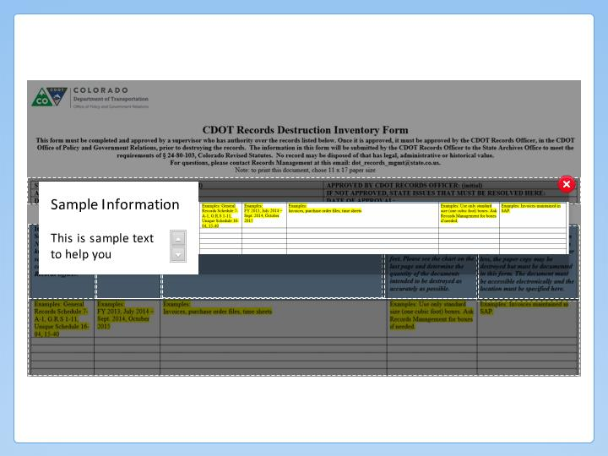

Step Text
This is sample text to help you understand how to complete the form. You can delete it or ignore it when you are completing the form.

Narration Script
The text highlighted in yellow is a sample of the type of information you can enter into the field. You can delete this content when you submit the form, or you can enter your data in the row underneath it. Now that we have gone through the form, let's look at the final step of boxing up the material.

