Record Destruction Box Label
Items: 7 Labels (Including Introduction)
Duration: 35 seconds

Introduction
5 seconds
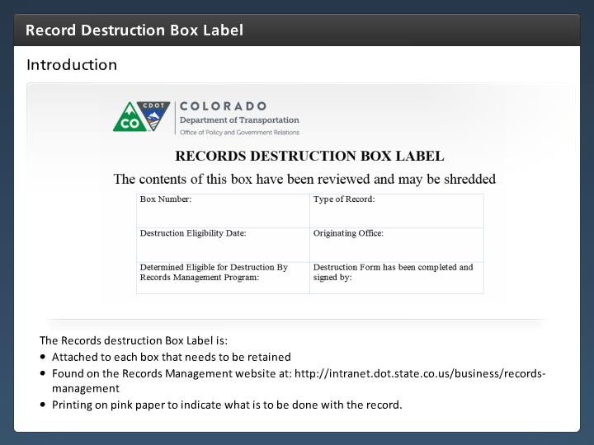

Step Text
The Records destruction Box Label is:
- Attached to each box that needs to be retained
- Found on the Records Management website at: http://intranet.dot.state.co.us/business/records-management
- Printing on pink paper to indicate what is to be done with the record.

Narration Script
The Record Destruction Box Label should be attached to each box after the it is determined that the paper records are going to be destroyed. In some cases, this may replace the orange storage label or the blue scanning label once it is determined the records are to be destroyed.

The form can be found on the Records Management web page, and should be printed on pink paper to indicate what is being done with the records. Now let's look at how to complete the form.

Box Number
5 seconds
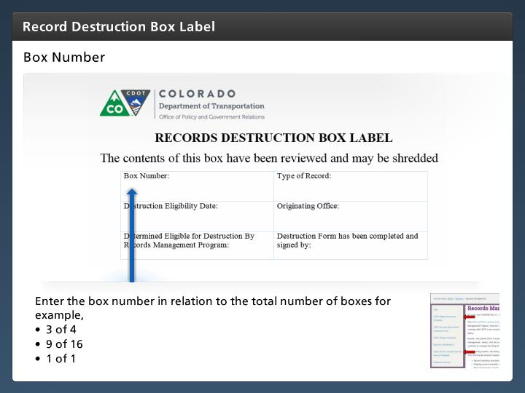

Step Text
Enter the box number in relation to the total number of boxes for example,
- 3 of 4
- 9 of 16
- 1 of 1

Narration Script
The first field you will need to fill in is the Box number. This should be entered with the number of the box in relation to the total number of boxes. For example box number three of four.

Type of Record
5 seconds
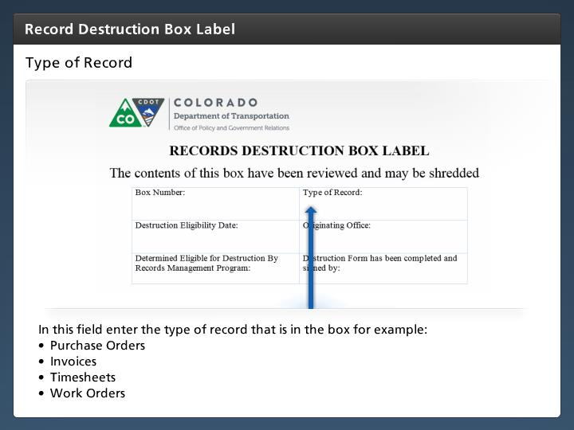

Step Text
In this field enter the type of record that is in the box for example:
- Purchase Orders
- Invoices
- Timesheets
- Work Orders

Narration Script
Next enter the type of record that is in the box. For example, timesheets, projects documents or invoices.

Destruction Eligibility Date
5 seconds
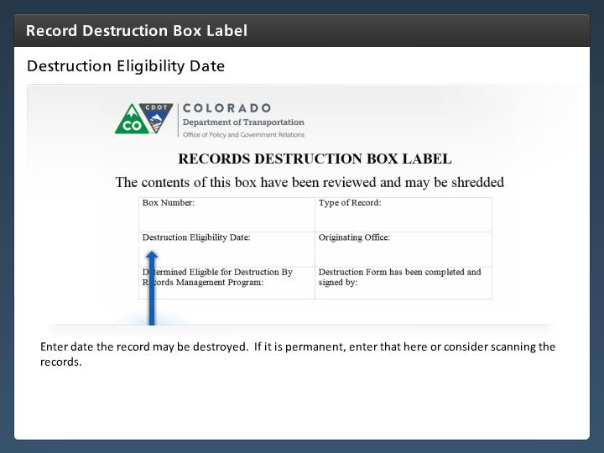

Step Text
Enter date the record may be destroyed. If it is permanent, enter that here or consider scanning the records.

Narration Script
Enter in the date on which the records can be destroyed. This is calculated by looking at the retention period on the records file plan and counting out that number of years from the date the office or division has determined the records may closed. For example, if the project file closed on 4/17/2016, and project files are retained for 3 years, the project file can be disposed of on 4/17/2019. If the office operates on a fiscal year, then purchase orders from FY 2010 can be destroyed on 6/30/2016 (the retention period under state general retention period 7-A-3 requires retention for 6 years and June 30th is the last day of the fiscal year. For permanent records enter "permanent" in this field

Originating Office
5 seconds
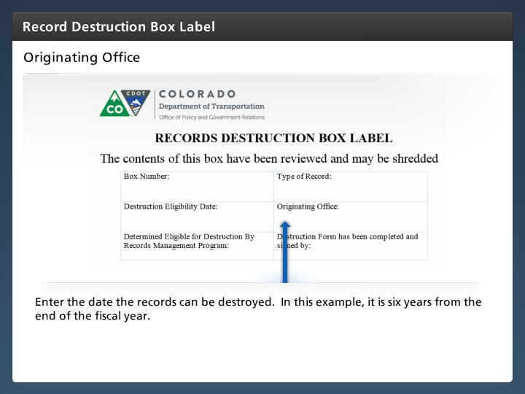

Step Text
Enter the date the records can be destroyed. In this example, it is six years from the end of the fiscal year.

Narration Script
The last field you will need to enter data is the origination office. This is the name or division that created the record or is responsible for the records you are placing in the box.

Determined Eligible for Destruction By RM Program
5 seconds
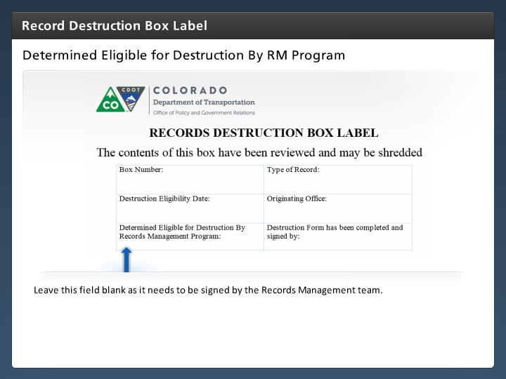

Step Text
Leave this field blank as it needs to be signed by the Records Management team.

Narration Script
This field is left blank, and is completed by the records management team who is responsible the final determination that the records may be destroyed.

Destruction Form has been completed and signed by
5 seconds
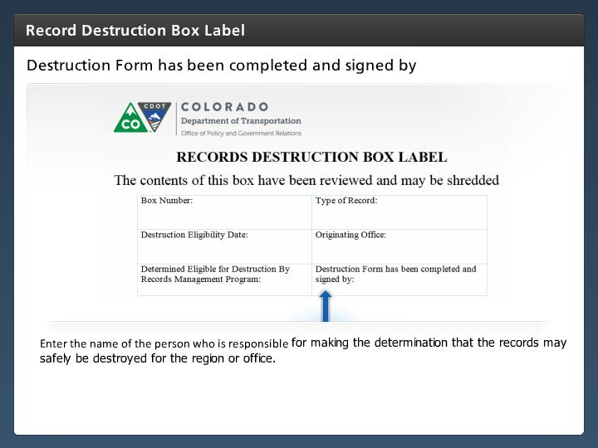

Step Text
Enter the name of the person who is responsible for making the determination that the records may safely be destroyed for the region or office.

Narration Script
When you complete this field you need to enter in the name of the person in your office who has knowledge of the record and is responsible for making the determination that the records may safely be destroyed for the region or office. This is most likely the person who created or signed-off on the record.

