Record Retention Box Label

Introduction
5 seconds
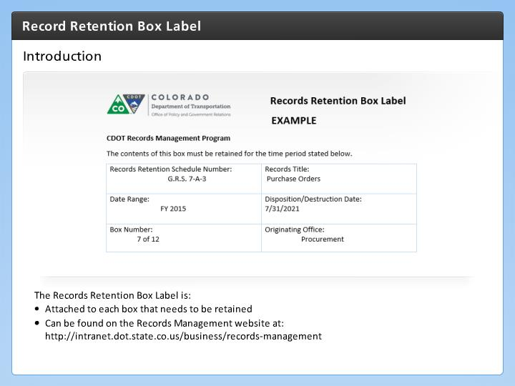

Step Text
The Records Retention Box Label is:
- Attached to each box that needs to be retained
- Can be found on the Records Management website at: http://intranet.dot.state.co.us/business/records-management

Narration Script
The Record Retention Box Label should be attached to each box after the it is determined that the paper records must be retained for a set period.

The form can be found on the Records Management web page.

Now let's look at how to complete the form.

Records Retention Schedule Number
5 seconds
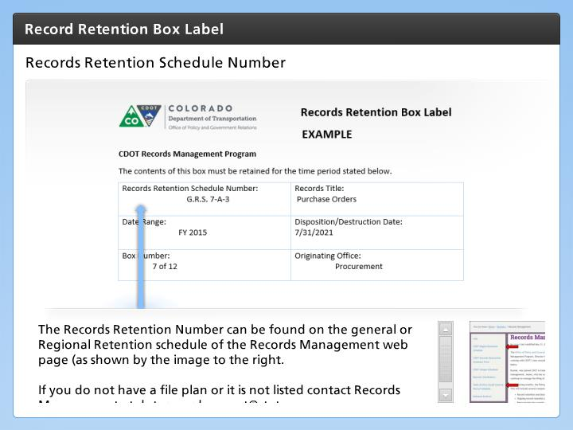

Step Text
The Records Retention Number can be found on the general or Regional Retention schedule of the Records Management web page (as shown by the image to the right.

If you do not have a file plan or it is not listed contact Records Management at dot_records_mgmt@state.co.us

Narration Script
The records retention schedule number is the number taken from the State Archives General Records Retention Schedule, or CDOT’s Unique Records Retention Schedule. This can also include reference to the United State Code, the Code of Federal Regulations, state statute or CDOT Procedural Directives. Refer to the file plan for your office or division to locate the records retention schedule number and enter it in this field.

If you do not have a file plan, or if the records you wish to retain are not listed on your file plan, contact the CDOT Records Officer at dot_records_mgmt@state.co.us to ask for assistance. It is the CDOT Records Officer’s responsibility, working with the Records Management Program and the Office of the Attorney General, to determine the correct retention period, taking into consideration any input from the specific division or office.

Records Title
5 seconds
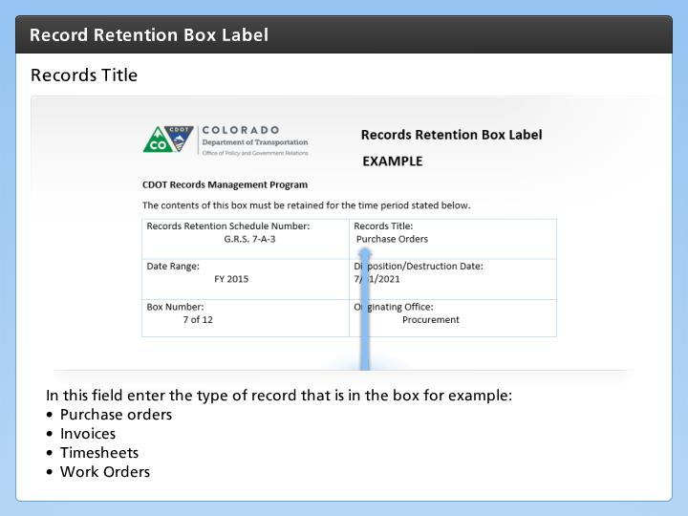

Step Text
In this field enter the type of record that is in the box for example:
- Purchase orders
- Invoices
- Timesheets
- Work Orders

Narration Script
Enter the title or name of the records you are boxing up and be sure not to mix different types of records together. For example, all invoices from the same year would be boxed together but personnel files would not be in the same box even if they are for the same year. Also, records that pertain to a certain project number must not be intermingled with other projects and lastly. Now let's look at the date range.

Date Range
5 seconds
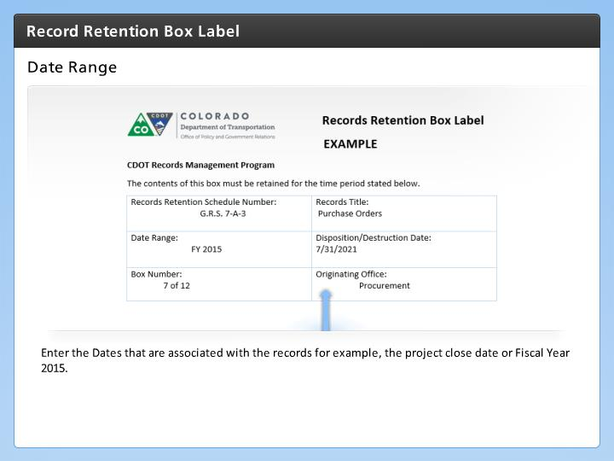

Step Text
Enter the Dates that are associated with the records for example, the project close date or Fiscal Year 2015.

Narration Script
Enter the date or date range for the records. For example If you have project records and the project closed on a certain date, write in the project closure date. If you have general ledgers for a fiscal year, then write the fiscal year applicable to the general ledgers.

Disposition/Destruction Date
5 seconds
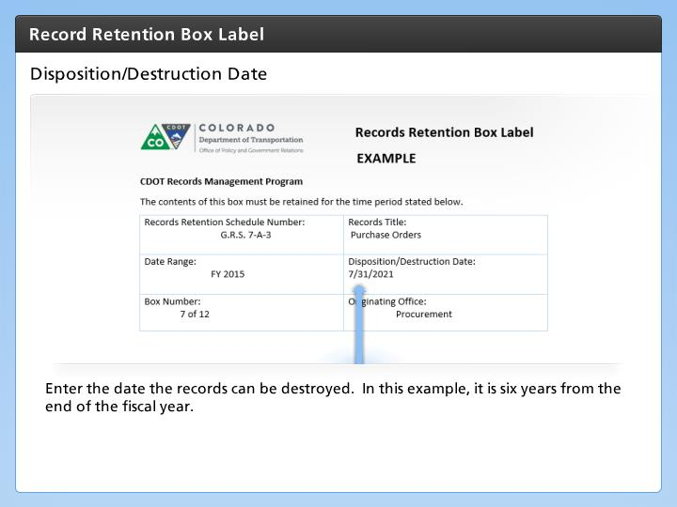

Step Text
Enter the date the records can be destroyed. In this example, it is six years from the end of the fiscal year.

Narration Script
Enter in the date on which the records can be destroyed. This is calculated by looking at the retention period on the records file plan and counting out that number of years from the date the office or division has determined the records may closed. For example, if the project file closed on 4/17/2016, and project files are retained for 3 years, the project file can be disposed of on 4/17/2019. If the office operates on a fiscal year, then purchase orders from FY 2010 can be destroyed on 6/30/2016 (the retention period under state general retention period 7-A-3 requires retention for 6 years and June 30th is the last day of the fiscal year. For permanent records enter "permanent" in this field

Box Number
5 seconds
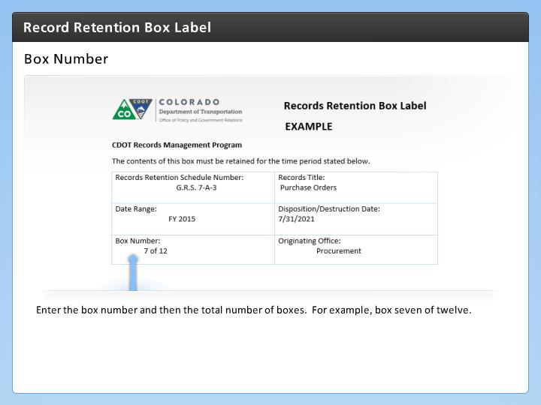

Step Text
Enter the box number and then the total number of boxes. For example, box seven of twelve.

Narration Script
In some cases you may have more than one box of records. If this is the case then enter the number of the box in relation to the total number in this example box seven of twelve. In this example, box seven of twelve.

Originating Office
5 seconds
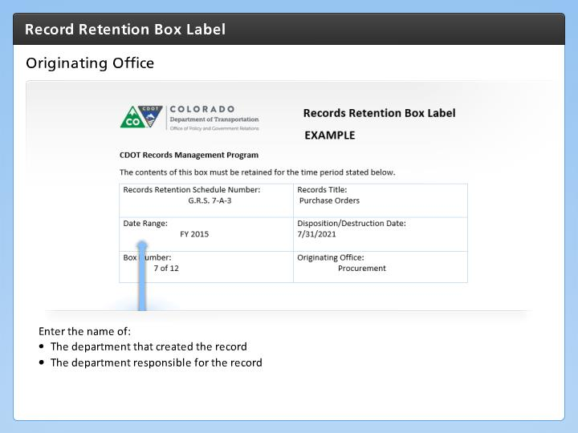

Step Text
Enter the name of:
- The department that created the record
- The department responsible for the record

Narration Script
The last field you will need to enter data is the origination office. This is the name or division that created the record or is responsible for the records you are placing in the box.

