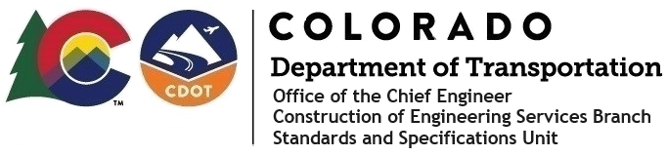

**Memorandum**

**Date**: September 30, 2024

**To**: All holders of Standard Special Provisions

**From**: Markos Atamo, Construction Engineering Services Branch Manager

**Subject**: Revised standard special provision: Revision of Sections 105, 106, 412, and

601 - PCCP Acceptance and Recycled Concrete Aggregate

As of September 30, 2024, this unit has issued the revised standard special provision, “Revision of Sections 105, 106, 412, and 601 - PCCP Acceptance and Recycled Concrete Aggregate”, with 15 pages, and dated September 30, 2024.

This provision added “& Recycled Concrete Aggregate” to the title, and revised Subsections: 105.06 - Conformity to the Contract of Portland Cement Concrete Pavement, 106.06 - Sampling and Testing of Portland Cement Concrete Paving, 412.24 - General, and 601.02 - Class P.

Use this on all projects with PCCP.

This standard special provision will become effective on projects with bid openings on or after October 29, 2024. You may use this standard special provision in projects advertised before this date.

For those of you who keep a book of Standard Special Provisions, please include this revised provision. For your convenience, this provision and the latest SSP Index are attached in the email. You can also find these in our Construction Specifications web pages: [Standard Special Provisions](https://www.codot.gov/business/designsupport/cdot-construction-specifications/2023-construction-specifications/rev-ssp/rev-sec100-ssp) and the [Recently Issued Special Provisions](https://www.codot.gov/business/designsupport/cdot-construction-specifications/2023-construction-specifications/recently-issued-special-provisions).

If you have any questions or comments, please contact this office.