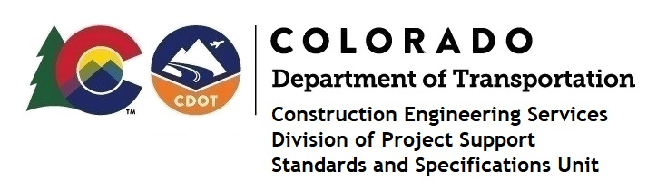
Memorandum

Date: June 4, 2024

To: All holders of Standard Special Provisions

From: Markos Atamo, Construction Engineering Services Branch Manager

Subject: New standard special provision: Revision of Section 105 – Pavement

Smoothness

As of June 4, 2024, this unit has issued the new standard special provision, “Revision of Section 105 – Pavement Smoothness”, with 11 pages, and dated July 1, 2024.

This specification requires a Planned Project Expense item for incentive payment.

This standard special provision will not to be used on projects with bid openings prior to July 1, 2024. It will become effective on projects with bid openings on or after July 1, 2024.

This provision replaced Subsection 105.07 - Conformity to Roadway Smoothness Criteria. Roadway smoothness testing and corrective work for hot mix asphalt and Portland cement concrete pavements shall be performed as described in this SSP.

For those of you who keep a book of Standard Special Provisions, please include this revised provision. For your convenience, this provision and the latest SSP Index are attached in the email. You can also find these in our Construction Specifications web pages: Standard Special Provisions and the Recently Issued Special Provisions.

If you have any questions or comments, please contact this office.

