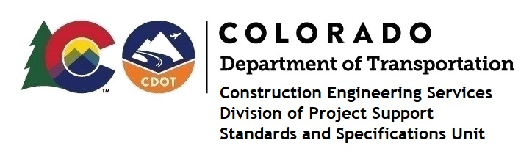

Memorandum

Date: May 31, 2024

To: All holders of Standard Special Provisions

From: Markos Atamo, Construction Engineering Services Manager

Subject: The Minimum Wages on Federal Aid Projects

Effective this date, our unit has issued the revised Minimum Wages, Colorado, U.S. Department of Labor, General Decision Number CO20240009 Mod 1 standard special provision. This revised standard special is 7 pages long and is dated May 31, 2024. It is to be included in all federal aid projects beginning with projects that have bid openings on June 10, 2024 or later. Use this standard special provision on all federal-aid projects with contracts exceeding $2000, except for non-ARRA projects on roadways classified as local roads or rural minor collectors, which are exempt. Projects on local roads, rural minor collectors, and enhancement projects funded with ARRA funds are not exempt.

Mod 1 changed the wages and fringe benefits for Carpenters (Form Work Only).

Project Managers: Please check to see if your projects are affected and take the appropriate action.

If you have any questions or comments, please contact this office.

