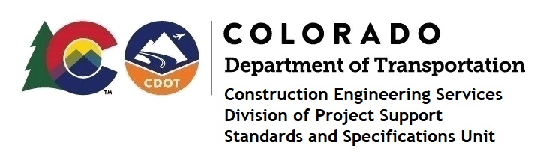
Memorandum

Date: May 16, 2024

To: All holders of Standard Special Provisions

From: Markos Atamo, Construction Engineering Services Branch Manager

Subject: New standard special provision: Revision of Sections 208, 213, and 216 –

Construction Permit Water Quality

As of May 16, 2024, this unit has issued the new standard special provision, “Revision of Sections 208, 213, and 216 – Construction Permit Water Quality”, with 24 pages, and dated May 16, 2024.

This standard special provision is to be used on all projects that hold a COR400000 permit (CDPS-SCP).

This provision revised various parts of subsections 208, 213, and 216.

Projects currently under design that require a CDPS-SCP must incorporate this Standard Special Provision into the specifications. Projects that are currently under Ad should pursue a Revision Under Ad to incorporate this SSP. Projects that have been awarded should refer to Construction Bulletin 2024, Number 2 for guidance. These instructions would similarly apply to any Local Agency projects meeting the same criteria.

For those of you who keep a book of Standard Special Provisions, please include this revised provision. For your convenience, this provision and the latest SSP Index are attached in the email. You can also find these in our Construction Specifications web pages: Standard Special Provisions and the Recently Issued Special Provisions.
If you have any questions or comments, please contact one of the following:
- MS4 Construction Program Manager: Kat Hoffman – katherine.hoffman@state.co.us
- Water Quality Construction Section Manager: Tripp Minges –
tripp.minges@state.co.us
- Or your Construction Area Engineer.

