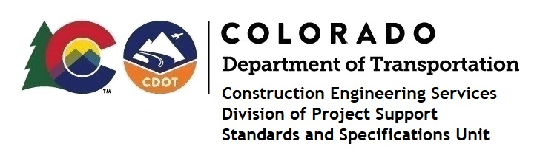

MEMORANDUM

DATE: November 1, 2022

TO: All holders of Standard Special Provisions

FROM: Shawn Yu, Standards and Specifications Unit Manager

SUBJECT: New standard special provision: Revision of Sections 101 and 106 – Buy America

Requirements

On November 1, 2022, our unit issued the new standard special provision, Revision of Sections 101 and 106 – Buy America Requirements, with 3 pages, and dated November 1, 2022. This Standard Special Provision applies to all federal-aid highway (FHWA) funded projects that will be advertised on or after November 10, 2022.

This specification revised Subsection 101.02 and Subsection 106.11 with additional information.

For those of you who keep a book of Standard Special Provisions, please include this new standard special provision. For your convenience, this specification and the latest SSP Index are attached in the email. You can also find these in our Construction Specifications web pages: Standard Special Provisions and the Recently Issued Special Provisions.

If you have any questions or comments, please contact this office.

