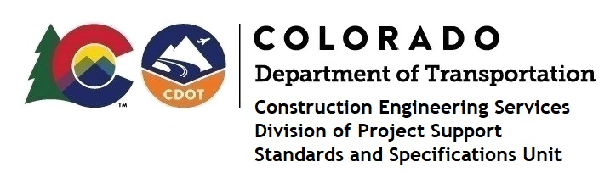

Memorandum

DATE: August 12, 2022

TO: All holders of Standard Special Provisions

FROM: Shawn Yu, Standards and Specifications Unit Manager

SUBJECT: The Minimum Wages on Federal Aid Projects

Effective today, August 12, 2022, our unit has issued the revised Minimum Wages, Colorado, U.S. Department of Labor, General Decision Number CO20220011, MOD 3, standard special provision. This revised standard special is 7 pages long, and is dated August 12, 2022. It is to be included immediately in all federal aid projects that had (or will have) bid openings on or after August 22, 2022. Use this standard special provision on all federal-aid projects with contracts exceeding $2000, except for non-ARRA projects on roadways classified as local roads or rural minor collectors, which are exempt. Projects on local roads, rural minor collectors, and enhancement projects funded with ARRA funds are not exempt.

MOD 3 changed the wages and fringe benefits for Dump Truck drivers in Kit Carson county.

If you have any questions or comments, please contact this office.

