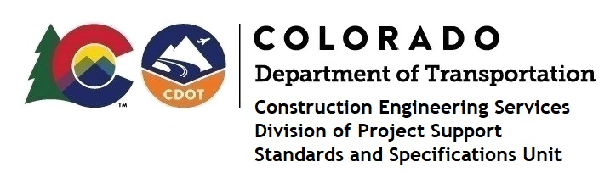

Memorandum

DATE: July 1, 2022

TO: All holders of Standard Special Provisions

FROM: Shawn Yu, Standards and Specifications Unit Manager

SUBJECT: The Minimum Wages on Federal Aid Projects

Effective this date, our unit is issuing the revised Minimum Wages, Colorado, U.S. Department of Labor, General Decision Number CO20220008 MOD 3 standard special provision. This revised standard special is 7 pages long, and is dated July 1, 2022. It is to be included in all federal aid projects beginning with projects that have bid openings on July 11, 2022 or later. Use this standard special provision on all federal-aid projects with contracts exceeding $2000, except for non-ARRA projects on roadways classified as local roads or rural minor collectors, which are exempt. Projects on local roads, rural minor collectors, and enhancement projects funded with ARRA funds are not exempt.

This decision changed the wage and fringe benefits for Electricians in El Paso and Teller counties only.

Project Managers: Please check to see if your projects are affected and take appropriate action. A Revision Under Ad is required for projects that are currently under advertisement with bid openings prior to July 11, 2022.

If you have any questions or comments, please contact this office.

