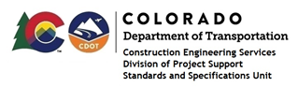

MEMORANDUM

DATE: June 21, 2022

TO: All holders of Standard Special Provisions

FROM: Shawn Yu, Standards and Specifications Unit Manager

SUBJECT: Issuance of new Standard Special Provision: Revision of Section 109 –

Scale Ticket Requirements

Effective this date, our unit has issued a new Standard Special Provision, Revision of Section 109 – Scale Ticket Requirements, with 1 page, and dated June 21, 2022. This Standard Special Provision will become effective on projects that will be advertised on or after July 21, 2022. Earlier use if permissible.

Please use this standard special provision on all projects.

This new provision adds more scale ticket information to Subsection 109.01.

For those of you who keep a book of Standard Special Provisions, please include this specification. For your convenience, this specification and the SSP Index are attached in the issuance email. You can also find them in our Construction Specifications web page: Standard Special Provisions and the “Recently Issued Special Provisions” webpage.

If you have any questions or comments, please contact this office.

