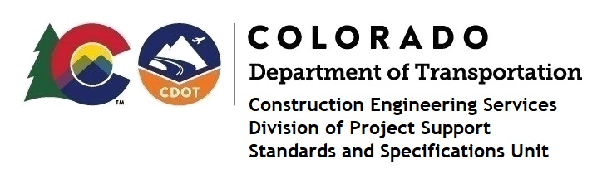

Memorandum

DATE: February 28, 2022

TO: All holders of Standard Special Provisions

FROM: Shawn Yu, Standards and Specifications Unit Manager

SUBJECT: The Minimum Wages on Federal Aid Projects

Effective February 25, 2022, our unit has issued the revised Minimum Wages, Colorado, U.S. Department of Labor, General Decision Number CO20220008 MOD 2 standard special provision. This revised standard special is 7 pages long, and is dated February 25, 2022. It is to be included immediately in all federal aid projects that had (or will have) bid openings on or after January 30, 2022. Also, for all federal aid projects if the contract was entered, renewed or extended (e.g., an option is exercised) on or after January 30, 2022. Use this standard special provision on all federal-aid projects with contracts exceeding $2000, except for non-ARRA projects on roadways classified as local roads or rural minor collectors, which are exempt. Projects on local roads, rural minor collectors, and enhancement projects funded with ARRA funds are not exempt.

MOD 2 raised the minimum Basic Hourly Wage rates to at least $15 for workers that made less before January 30^{th,} 2022. Please see the “Minimum Wage Rates” table added on page 6 for complete information. The number of pages have increased to seven.

Project Managers: Please check to see if your projects are affected and take appropriate action. A Revision Under Ad will be required for projects that have already been advertised on or after January 30, 2022.

If you have any questions or comments, please contact this office.

