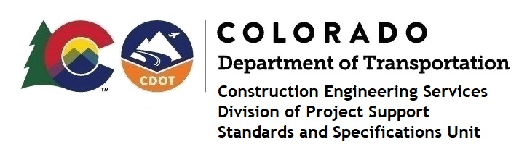

Memorandum

DATE: February 18, 2022

TO: All holders of Standard Special Provisions

FROM: Shawn Yu, Standards and Specifications Unit Manager

SUBJECT: The Minimum Wages on Federal Aid Projects

Effective this date, our unit is issuing the revised Minimum Wages, Colorado, U.S. Department of Labor, General Decision Number CO20220012 MOD 1 standard special provision. This revised standard special is 9 pages long, and is dated February 18, 2022. It is to be included in all federal aid projects beginning with projects that have bid openings on February 28, 2022 or later. Use this standard special provision on all federal-aid projects with contracts exceeding $2000, except for non-ARRA projects on roadways classified as local roads or rural minor collectors, which are exempt. Projects on local roads, rural minor collectors, and enhancement projects funded with ARRA funds are not exempt.

This decision changed the wage and fringe benefits for Electricians in all counties under the Collectively Bargained Rates. It also deleted the “(Boom Truck Operator)” description under Classification, next to Electricians.

If you have any questions or comments, please contact this office.

