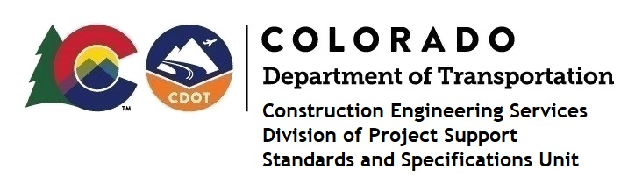

MEMORANDUM

DATE: October 26, 2021

TO: All holders of Standard Special Provisions

FROM: Shawn Yu, Standards and Specifications Unit Manager

SUBJECT: New standard special provision: Revision of Section 105 – Control of Work

Effective this date, our unit has issued the new standard special provision, Revision of Section 105 – Control of Work, with 1 page, and dated October 26, 2021. It is to be used on all projects.

This revision added instructions about retainage.

This new provision is effective on all projects advertised on or after November 25, 2021. Earlier use of it is acceptable.

For those of you who keep a book of Standard Special Provisions, please include this revised standard special provision. For your convenience, this specification and the latest SSP Index are attached in the email. You can also find these in our Construction Specifications web pages: Standard Special Provisions and the Recently Issued Special Provisions.

If you have any questions or comments, please contact this office.

