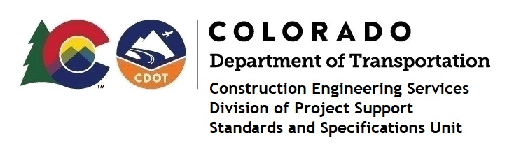

MEMORANDUM

DATE: June 18, 2021

TO: All holders of Standard Special Provisions

FROM: Shawn Yu, Standards and Specifications Unit Manager

SUBJECT: Revised standard special provision: Revision of Section 108 – Liquidated

Damages

Effective this date, our unit has issued revised standard special provision, Revision of Section 108 – Liquidated Damages, with 1 page, and dated June 18, 2021.

This revised specification has updated the Schedule of Liquidated Damages table in subsection 108.09 - Failure to Complete Work on Time.

This specification is effective on projects advertised on or after July 15, 2021. Earlier use of it is acceptable.

For those of you who keep a book of Standard Special Provisions, please include this revised standard special provision. For your convenience, this specification and the latest SSP Index are attached in the email. You can also find these in our Construction Specifications web pages: Standard Special Provisions and the Recently Issued Special Provisions.

If you have any questions or comments, please contact this office.

