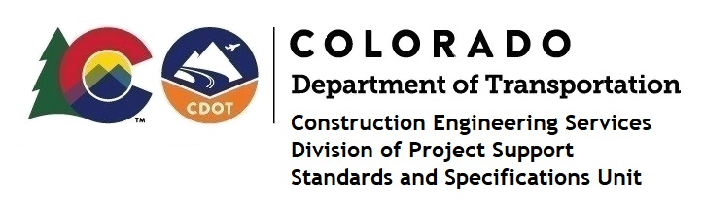

MEMORANDUM

DATE: June 23, 2021

TO: All holders of Standard Special Provisions

FROM: Shawn Yu, Standards and Specifications Unit Manager

SUBJECT: New standard special provision: Revision of Section 101 - Definitions and Terms

Effective this date, our unit has issued new standard special provision, Revision of Section 101 - Definitions and Terms, with 1 page, and dated June 23, 2021.

This revision revised the definition of 101.81 – Subcontractor and added the definition for 101.81.5 - Supplier.

This specification is effective on all projects advertised on or after July 1, 2021. Earlier use of it is acceptable.

For those of you who keep a book of Standard Special Provisions, please include this new standard special provision. For your convenience, this specification and the latest SSP Index are attached in the email. You can also find these in our Construction Specifications web pages: Standard Special Provisions and the Recently Issued Special Provisions.

If you have any questions or comments, please contact this office.

