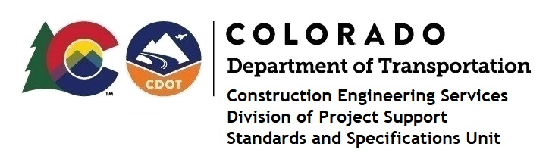

MEMORANDUM

DATE: May 18, 2021

TO: All holders of Standard Special Provisions

FROM: Shawn Yu, Standards and Specifications Unit Manager

SUBJECT: Two new standard special provisions: Revision of Control of Work (105.22) and

(Audit)

Effective this date, our unit has issued two new standard special provisions, Revision of Section Control of Work (105.22) and Revision of Section Control of Work (Audit), with 2 pages each, and dated May 18, 2021.

These specifications revised subsections 105.22, 105.23, and 105.24.

Please use these provisions on all projects, beginning with projects advertised on or after June 10, 2021. Earlier use is acceptable.

For those of you who keep a book of Standard Special Provisions, please include these new special provisions. For your convenience, these specifications and the latest SSP Index are attached in the email. You can also find these in our Construction Specifications web pages: Standard Special Provisions and the Recently Issued Special Provisions.

If you have any questions or comments, please contact this office.

