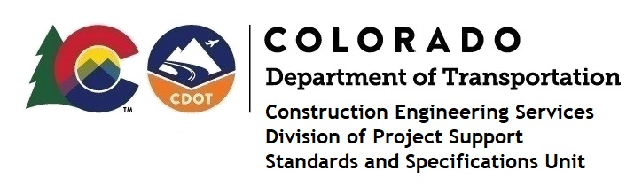

MEMORANDUM

DATE: January 20, 2021

TO: All holders of Standard Special Provisions

FROM: Shawn Yu, Standards and Specifications Unit Manager

SUBJECT: New standard special provision: Revision of Section 104 – Scope of Work

Effective this date, our unit has issued the new standard special provision, Revision of Section 104 – Scope of Work, with 1 page, and dated January 20, 2021.

This specification revised subsections 104.07 (b) (3) and 104.07 (d) (3).

Please use this provision on all projects, beginning with projects advertised on or after February 18, 2021. Earlier use is acceptable.

For those of you who keep a book of Standard Special Provisions, please include this new special provision. For your convenience, this specification and the latest SSP Index are attached in the email. You can also find these in our Construction Specifications web pages: Standard Special Provisions and the Recently Issued Special Provisions.

If you have any questions or comments, please contact this office.

