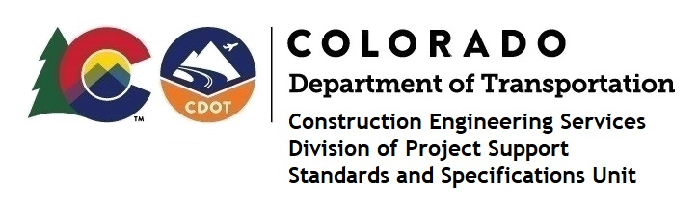

MEMORANDUM

DATE: December 16, 2020

TO: All holders of Standard Special Provisions

FROM: Shawn Yu, Standards and Specifications Unit Manager

SUBJECT: New standard special provision: Revision of Section 101 – Record Set

Effective this date, our unit has issued the new standard special provision, Revision of Section 101 – Record Set, with 1 page, and dated December 16, 2020.

Use this standard special provision on all projects on or after January 18, 2021. Earlier use is acceptable.

This specification requires Record Sets be sealed using Adobe Sign software per regulation “4 CCR 730-1”.

For those of you who keep a book of Standard Special Provisions, please include this new special provision. For your convenience, this specification and the latest SSP Index are attached in the email. You can also find these in our Construction Specifications web pages: Standard Special Provisions and the Recently Issued Special Provisions.

If you have any questions or comments, please contact this office.

