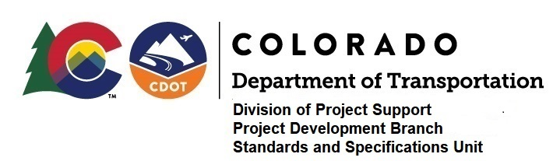

MEMORANDUM

DATE: April 13, 2020

TO: All holders of Standard Special Provisions

FROM: Shawn Yu, Standards and Specifications Unit Manager

SUBJECT: Revision of Section 107 - Project Safety Management Plan

Effective this date, our unit is issuing a new standard special provision, Revision of Section 107 - Project Safety Management Plan. This new standard special provision is 1-page long.

This standard special provision is for use on all projects.

With the development of the Coronavirus pandemic, subsection 107.06 (a) has been revised so that the Contractor shall prepare a project specific safety management plan to include these additional provisions and protocols. Previously prepared and accepted safety management plans shall be updated to include this information.

Please use this provision on all projects, beginning with projects advertised on or after April 23, 2020.

For those of you who keep a book of Standard Special Provisions, please include this specification. For your convenience, you can find this in one place on our Construction Specifications web page: https://www.codot.gov/business/designsupport/cdot-construction-specifications/2019-construction-specifications/rev-ssp/rev-sec100-ssp/107smp/view

You may also visit the hyperlink, “Recently Issued Special Provisions”.

If you have any questions or comments, please contact this office.

