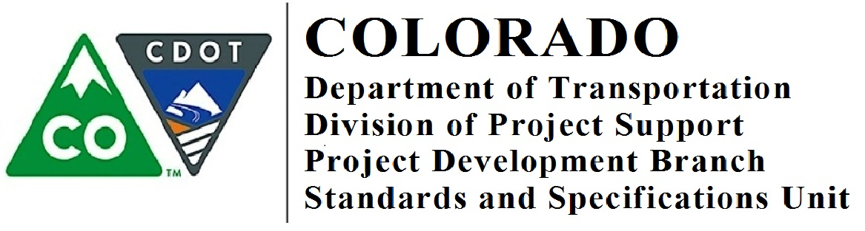

Memorandum

DATE: August 28, 2018

TO: All Holders of Standard Special Provisions

FROM: Shawn Yu, Standards and Specifications Engineer

SUBJECT: New On the Job Training standard special provisions

Effective this date, our unit is issuing a new standard special provision:
- On the Job Training (4 pages)
This standard special provision replace the previous standard special provision titled, On The Job Training, dated July 3, 2017.
Please use the On the Job Training special provision on all Federal-aid projects, including local agency projects, except for local agency projects where the local agency will not use LCPtracker for reporting.
Use this standard special provision on all federal aid projects beginning with projects advertised after September 6, 2018.
Those of you who keep a book of Standard Special Provisions, you may add these standard special provisions to your file. For your convenience, you can find these and all other special provisions in one place at our Construction Specifications web page:

https://www.codot.gov/business/designsupport/cdot-construction-specifications/2017-construction-standard-specs, or only past issued special provisions with this “Recently Issued Special Provisions” link.

If you have any questions or comments, please contact this office.

