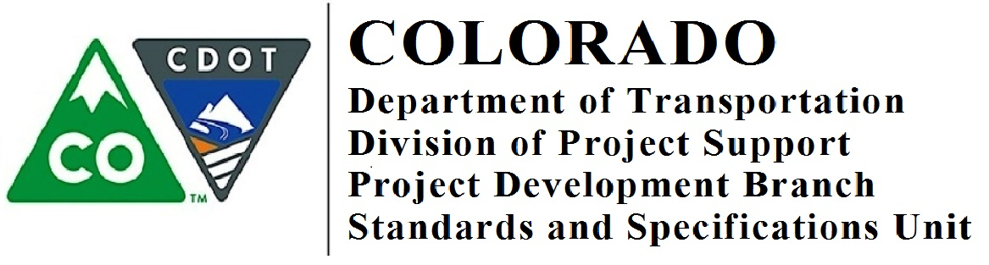

Memorandum

DATE: June 12, 2018

TO: All Holders of Standard Special Provisions

FROM: Shawn Yu, Standards and Specifications Engineer

SUBJECT: Revision of Section 504 – Concrete Panel Facing MSE Walls
Effective this date, our unit is issuing a new standard special provision, Revision of Section 504 – Concrete Panel Facing MSE Walls. This new standard special provision is 12 page long.

Please use this new standard special provision in all projects that have Concrete Panel Facing MSE walls on projects advertised on or after July 12, 2018. You are free to use this standard special provision in projects advertised before this date.

This new standard special provision was created to meet the AASHTO LRFD (Fifth Edition) Bridge Design Specification.

For those of you who keep a book of Standard Special Provisions, please add this new standard special provision to your file. For your convenience, you can find this and others special provisions on our Construction Specifications website or you may visit our Recently Issued Special Provisions website.

If you have any questions or comments, please contact this office.

