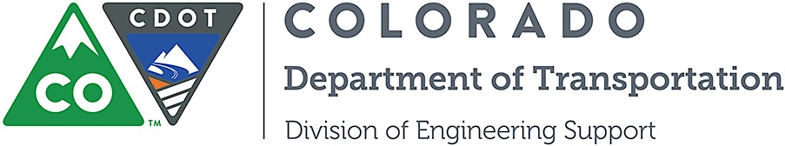

Project Development Branch
Standards and Specifications Unit

Memorandum

DATE: May 8, 2014

TO: All holders of Standard Special Provisions

FROM: Larry Brinck, Standards and Specifications Engineer

SUBJECT: Minimum Wages on Federal Aid Projects. General Decision Number - CO140024, MOD 1
Attached is a copy of the Minimum Wage, Colorado, U.S. Department of Labor General Decision Number CO140024, MOD 1, Highway Construction for Larimer, Mesa, and Weld counties. It is 7 pages long and dated January 24, 2014. It is to be included in all federal aid projects beginning with projects that have bid openings on June 05, 2014 or later. You are free to use it in projects advertised before this date. Use this standard special provision on all federal-aid projects with contracts exceeding $2000, except for non-ARRA projects on roadways classified as local roads or rural minor collectors, which are exempt. Projects on local roads, rural minor collectors, and enhancement projects funded with ARRA funds are not exempt.

This new Minimum Wages specification applies only to the projects taking place within the counties listed in this specification.
This new standard special provision replaces the standard special provision Minimum Wages Colorado U.S. Department of Labor, General Decision Numbers CO140016 through CO140024, Highway Construction, dated April 4, 2014.

If you have any questions or comments, please contact this office.

