MEMORANDUM

DEPARTMENT OF TRANSPORTATION
Project Development Branch, Standards and Specifications Unit

4201 East Arkansas Avenue
Denver, Colorado 80222
(303)757-9474
FAX (303)757-9820
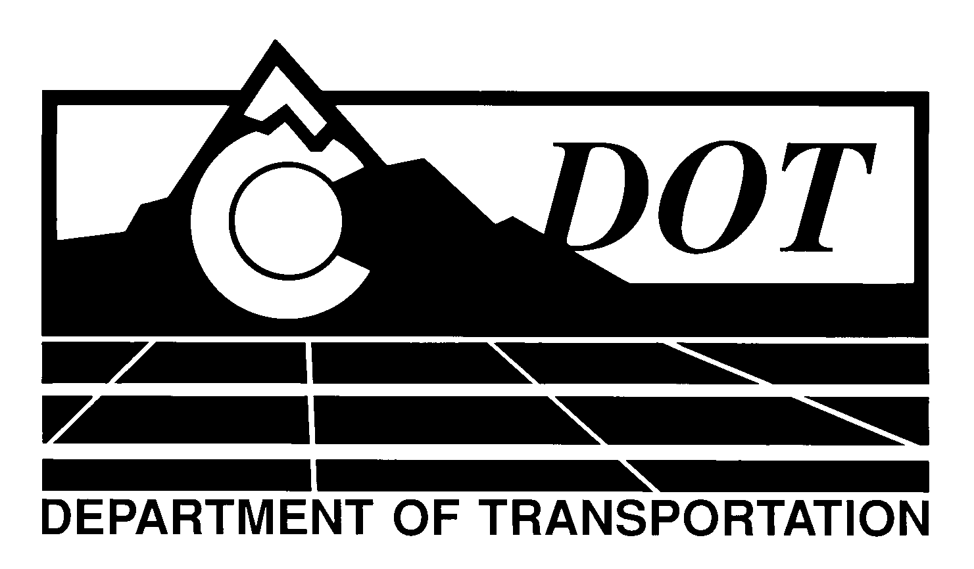

DATE: January 30, 2014

TO: All Holders of Standard Special Provisions

FROM: Larry Brinck, Standards and Specifications Engineer

SUBJECT: Revision of Sections 105 and 106, Conformity to the Contract of

Hot Mix Asphalt (Voids Acceptance)

Effective this date, our unit is issuing a revised version of the Standard Special Provision, Revision of Sections 105 and 106, Conformity to the Contract of Hot Mix Asphalt (Voids Acceptance). This revised standard special is 10 pages long, and should be used in projects with 5000 or more tons of hot mix asphalt when acceptance is based on air voids, and other elements.

Use of this revised Standard Special Provision is mandatory on projects advertised on or after February 27, 2014. You are free, however, to use it in projects advertised before this date.

This revised standard special replaces the now obsolete version dated February 3, 2011. It corrects a minor error in Table 106-1 by referencing note 1 in the acceptance column for Determining Percent Relative Compaction of Bituminous Pavement and Joint Density.

Those of you who keep books of Standard Special Provisions should replace the now obsolete Standard Special Provision with this revised version. The CDOT Construction Specifications web site has been updated to reflect the issuance of this and other special provisions.

For your convenience, a new Index of Standard Special Provisions is attached for your reference. In addition, you will find this new standard special provision and other special provisions that have been issued effective this date in one place on the web site:

http://www.coloradodot.info/business/designsupport/construction-specifications/2011-Specs/recently-issued-special-provisions

If you have any questions or comments, please contact this office.

LB/ms

Attachments

Distribution: Per distribution list

