MEMORANDUM

DEPARTMENT OF TRANSPORTATION
Project Development Branch, Standards and Specifications Unit

4201 East Arkansas Avenue
Denver, Colorado 80222
(303)757-9474
FAX (303)757-9820
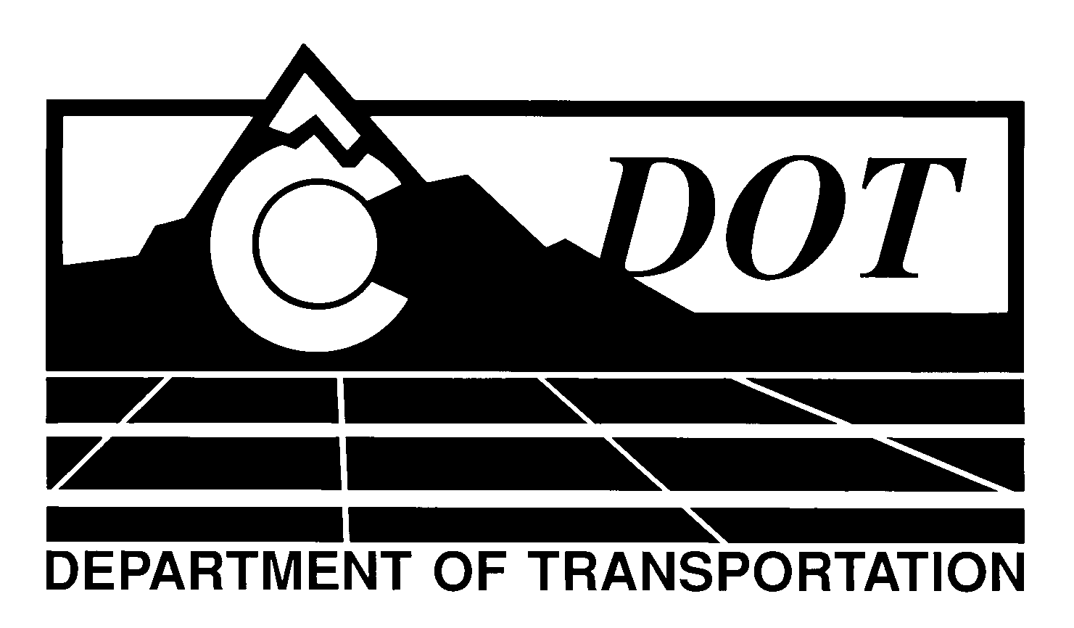

DATE: October 31, 2013

TO: All Holders of Standard Special Provisions

FROM: Larry Brinck, Standards and Specifications Engineer

SUBJECT: Required Contract Provisions, Federal-Aid Construction Contracts

Effective this date, our unit is issuing a revised version of the Required Contract Provisions Federal-Aid Construction Contracts. This revised standard special is 14 pages long, and replaces the Standard Special Provision of the same title dated July 19, 2012. It should be used on Federal-aid projects, beginning with projects advertised on or after November 29, 2013. You are free, however, to use it in projects advertised on or before this date.

This revision deletes the second paragraph of the opening instructions, which is now included in Form 1273. It also defines the exemptions to Form 1273 in TAP Recreational Trail funded projects.

Those of you who keep books of Standard Special Provisions should replace the now obsolete Standard Special Provision with this revised version. The CDOT Construction Specifications web site has been updated to reflect the issuance of this and other special provisions.

For your convenience, however, you will find this standard special provision and other special provisions that have been issued effective this date in one place on the web site:

http://www.coloradodot.info/business/designsupport/construction-specifications/2011-Specs/recently-issued-special-provisions

If you have any questions or comments, please contact this office.

LB/ms

Attachments

Distribution: Per distribution list

