MEMORANDUM

DEPARTMENT OF TRANSPORTATION
Project Development Branch, Standards and Specifications Unit

4201 East Arkansas Avenue
Denver, Colorado 80222
(303)757-9474
FAX (303)757-9820
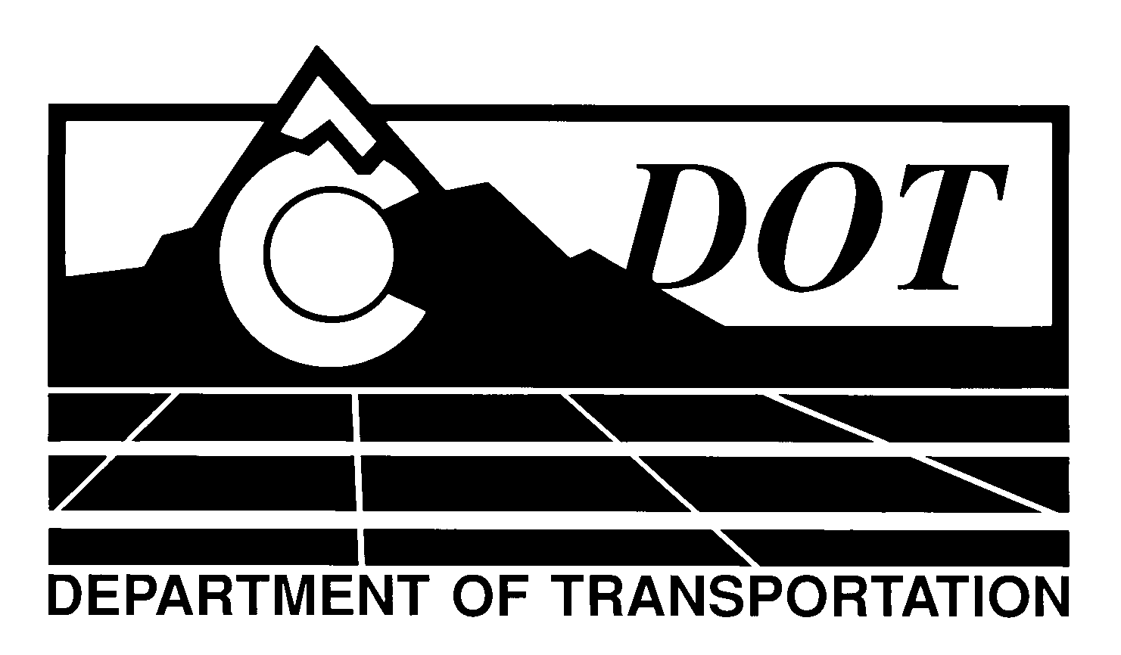

DATE: October 31, 2013

TO: All Holders of Standard Special Provisions

FROM: Larry Brinck, Standards and Specifications Engineer

SUBJECT: Revision of Section 106, Material Sources

Effective this date, our unit is issuing a new standard special provision, Revision of Section 106, Material Sources. This new standard special provision is 1 page long, and should be used in all projects. Use of this new special provision is mandatory on projects advertised on or after November 28, 2013. You are free, however, to use it in projects advertised before this date.

This new standard special provision clarifies that CDOT will perform the initial test of Contractor source material. If the material does not meet CDOT Specifications, it becomes the Contractor’s responsibility to re-sample and test the material. The Contractor shall be responsible for all costs incurred from the sampling, testing and necessary corrective action.

Those of you who keep books of Standard Special Provisions should add this new special provision to your file. The CDOT Construction Specifications web site has been updated to reflect the issuance of this and other special provisions.

For your convenience, however, you will find this new standard special provision and other special provisions that have been issued effective this date in one place on the web site:

http://www.coloradodot.info/business/designsupport/construction-specifications/2011-Specs/recently-issued-special-provisions

If you have any questions or comments, please contact this office.

LB/ms

Attachments

Distribution: Per distribution list

