MEMORANDUM

DEPARTMENT OF TRANSPORTATION
Project Development Branch, Standards and Specifications Unit

4201 East Arkansas Avenue
Denver, Colorado 80222
(303)757-9474
FAX (303)757-9820
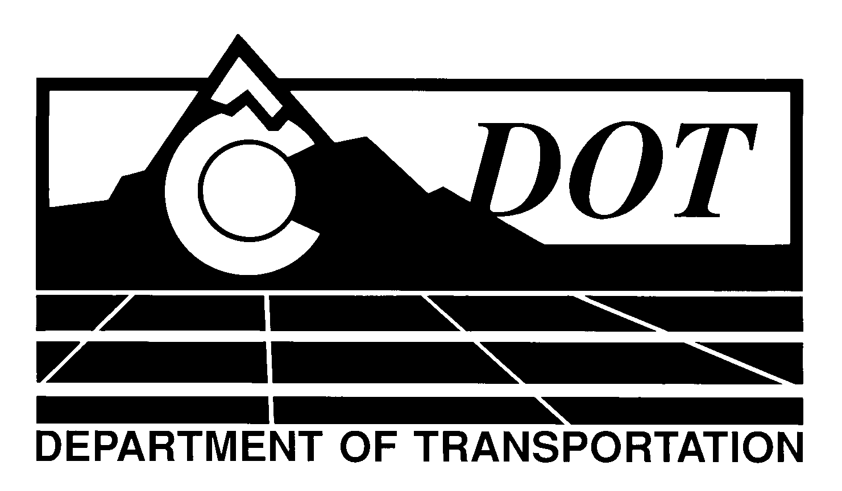

DATE: May 2, 2013

TO: All Holders of Standard Special Provisions

FROM: Larry Brinck, Standards and Specifications Engineer

SUBJECT: Revision of Section 107, Project Payrolls

The attached document is a new standard special provision, Revision of Section 107, Project Payrolls. This new standard special provision is 1 page long. It is required in all projects advertised on or after May 30, 2013. You may use it in projects advertised before this date.

This new standard special provision is associated with Form FHWA 1273 and requires the Contractor to check all Contractor and subcontractor project payrolls regarding accuracy of pay classification, pay hours, and pay rates. The Contractor shall sign and date all payrolls signifying this check has been performed.

Those of you who keep books of Standard Special Provisions should add this new special provision to your file. The CDOT Construction Specifications web site has been updated to reflect the issuance of this and other special provisions.

For your convenience, however, you will find this new standard special provision and other special provisions that have been issued effective this date in one place on the web site:

http://www.coloradodot.info/business/designsupport/construction-specifications/2011-Specs/recently-issued-special-provisions

If you have any questions or comments, please contact this office.

LB/ms
Attachments
Distribution: Per distribution list

