MEMORANDUM

DEPARTMENT OF TRANSPORTATION
Project Development Branch

4201 East Arkansas Avenue
Denver, Colorado 80222
(303)757-9040
FAX (303)757-9868
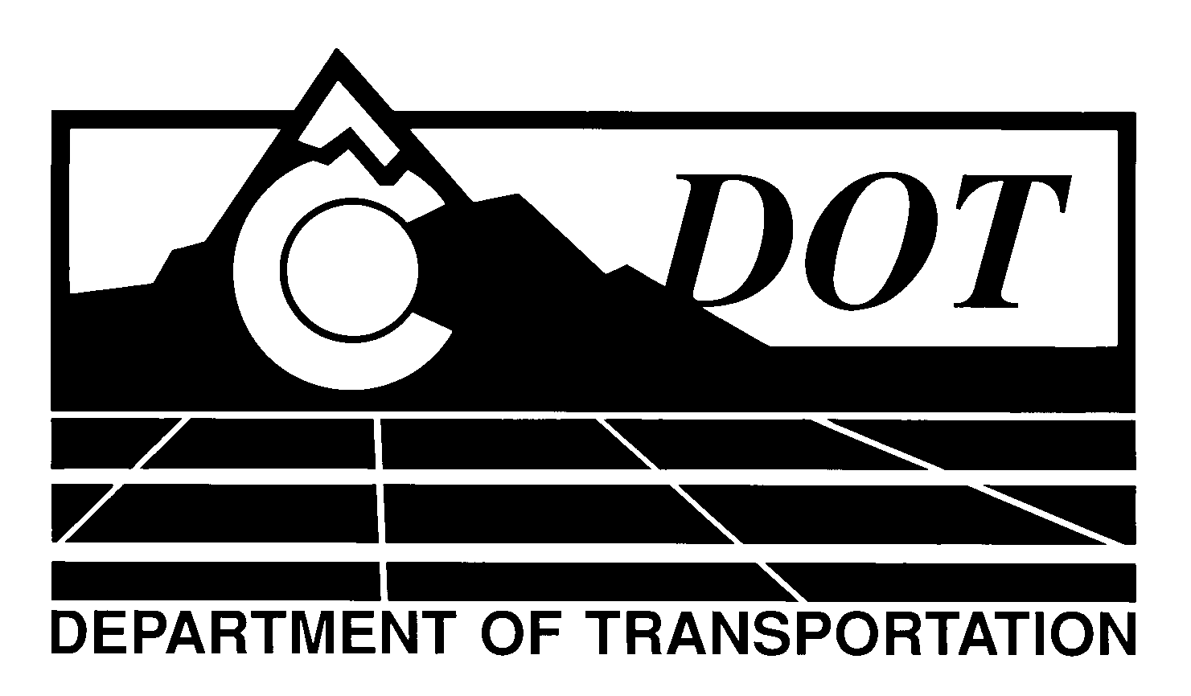

DATE: July 19, 2012

TO: All Holders of Standard Special Provisions

FROM: Larry Brinck, Standards and Specifications Engineer

SUBJECT: Revision of Sections 412 and 709, Tie Bars

Effective this date, our unit is issuing a new standard special provision, Revision of Sections 412 and 709, Tie Bars . This new standard special is 1 page long. It should be used in projects having PCCP, beginning with projects advertised on or after August 16, 2012. Please feel free, however, to include it in projects advertised before this date.

This new standard special provision allows for tie bar sizing to be determined by type of base, instead of pavement thickness. Tie bar spacing is increased to 36 inches, and tie bar steel grade changed to Grade 60. In addition, the special provision defines repair methods when tie bars are cut, missing or placed too low in the slab. This special provision should be used in conjunction with revised Standard Plans M-412-1 and M-609-1.

Those of you who keep books of Standard Special Provisions should add this to your file. For your convenience, we are attaching a new Index of Standard Special Provisions, effective this same date. In addition, you will find this and other special provisions that are being issued this date in one place in the CDOT Construction Specifications web site:

http://www.coloradodot.info/business/designsupport/construction-specifications/2011-Specs

Please click on the hyperlink titled “Recently Issued Special Provisions”.

LB/mrs

Attachments

Distribution: Per distribution list

