MEMORANDUM

DEPARTMENT OF TRANSPORTATION
Project Development Branch

4201 East Arkansas Avenue
Denver, Colorado 80222
(303)757-9040
FAX (303)757-9868
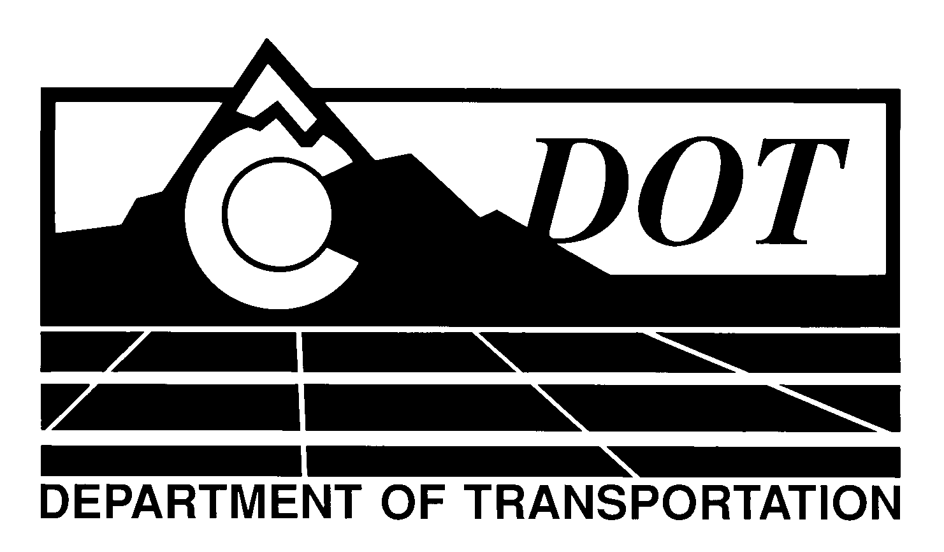

DATE: December 29, 2011

TO: All Holders of Standard Special Provisions

FROM: Larry Brinck, Standards and Specifications Engineer

SUBJECT: Revision of Section 614, Blank Out Sign (LED) (Speed Radar)

Effective this date, our unit is issuing new standard special provision, Revision of Section 614, Blank Out Sign (LED) (Speed Radar). This new standard special is 6 pages long. It should be used in projects having blank out signs, with speed radar capability, beginning with projects advertised on or after January 26, 2011. Please feel free, however, to include it in projects advertised before this date.

This new standard special provision defines the requirements for LED blank out sign with speed radar capabilities.

Those of you who keep books of Standard Special Provisions should add this new one to your file. For your convenience, we are attaching a new Index of Standard Special Provisions, dated December 29, 2011. In addition, you will find this and other special provisions that are being issued this date in one place in the CDOT Construction Specifications web site:

http://www.coloradodot.info/business/designsupport/construction-specifications/2011-Specs

Please click on the hyperlink titled “Recently Issued Special Provisions” to access this and other special provisions that have been issued as of this date.

LB/mrs

Attachments

Distribution: Per distribution list

